
SVKM’s INSTITUTE OF TECHNOLOGY, DHULE
Department of Information Technology
Academic Year 2025-26

Experiment 7

Name: Bhupesh Anil Suryawanshi
Roll No.: 63
Batch: B3

Aim : Implement defuzzification (Max-membership principle, Centroid method, Weighted average method).
Theory:
Defuzzification is the process of converting a fuzzy output from a fuzzy inference system into a crisp numerical value. It is the inverse of fuzzification, which transforms crisp inputs into fuzzy sets.
Defuzzification provides a clear decision or control action from fuzzy results and is essential for real-world applications like control systems.
The fuzzy output may consist of several overlapping membership functions, and the defuzzification process determines one representative crisp value using mathematical methods.
Defuzzification Methods
- Max Membership Principle (Height Method)
In this method, the crisp output corresponds to the value of the variable that has the highest degree of membership in the output fuzzy set.
Mathematically:
𝑥∗ = argmax_{𝑥} [𝜇(𝑥)]
Where:
  - 𝑥∗= defuzzified (crisp) output
  - 𝜇(𝑥)= membership function value
It is simple and computationally efficient, but works best when the fuzzy output set has a single peak (unimodal) shape.
- Centroid Method (Center of Gravity / Center of Area)
This is the most commonly used method in fuzzy logic systems. It finds the point 𝑥∗that divides the area under the curve of the fuzzy set into two equal parts — similar to finding the center of gravity of an object.
Mathematically:
∗ = ∫𝑥 𝜇(𝑥) 𝑑𝑥
𝑥
∫𝜇(𝑥) 𝑑𝑥

Where:
  - The numerator represents the “moment” of the area.
  - The denominator represents the total area under the membership curve.
This method provides smooth and balanced outputs, making it ideal for control applications such as fuzzy controllers in air conditioners and washing machines.
- Weighted Average Method
In this method, each fuzzy set’s representative value (usually its peak) is multiplied by its maximum membership value (weight), and the final output is the weighted average of these values.
Mathematically:
𝑥∗ = ∑𝑖 𝜇𝑖(𝑥𝑖) 𝑥𝑖

∑𝑖 𝜇_{𝑖}(𝑥_{𝑖})

Where:
  - 𝑥_{𝑖}= representative (peak) value of each membership function
  - 𝜇_{𝑖}(𝑥_{𝑖})= maximum membership value of each fuzzy set
This method is simpler than the centroid method and is often used when membership functions do not overlap significantly.
Advantages:
  - It provides clear numeric results from fuzzy data.
  - It is simple and practical for real-time control.
  - It allows smooth and stable system responses.
  - It supports multiple techniques for flexibility.

Disadvantages:
  - It can lose information while converting fuzzy data to a crisp value.
  - It may produce inaccurate results if fuzzy sets overlap.
  - It can be computationally complex for large systems.
  - It depends on the proper choice of method.
Applications:
  - It is used in fuzzy control systems (temperature, speed, washing machines).
  - It is applied in decision-making and expert systems.
  - It is used in industrial automation and robotics.
  - It helps in real-time adaptive control systems.
Conclusion:
Thus, Defuzzification was successfully implemented using Max Membership Principle, Centroid Method, and Weighted Average Method. It effectively converts fuzzy outputs into crisp values for real-world control and decision-making applications.
Program:
# Max-Membership Principle import numpy as np import skfuzzy as fuzz import matplotlib.pyplot as plt

# 1. Define the universe of discourse for the output variable.
# np.arange creates a NumPy array. Here, it will produce 101 elements from 0 to 10. x = np.arange(0, 10.1, 0.1)

# 2. Define the trapezoidal fuzzy membership function.
# The parameters [a, b, c, d] must be within the range of x.
# Example: [3, 5, 7, 9] fits within the universe of discourse [0, 10.1]. abcd = [3, 5, 7, 9] mfx = fuzz.trapmf(x, abcd)
# 3. Verify that the dimensions match before plotting. print(f"Shape of x: {x.shape}") print(f"Shape of mfx: {mfx.shape}")

# 4. Defuzzify using different methods.
fom_val = fuzz.defuzz(x, mfx, 'som') # Smallest of Maximum lom_val = fuzz.defuzz(x, mfx, 'lom') # Largest of Maximum mom_val = fuzz.defuzz(x, mfx, 'mom') # Mean of Maximum

# 5. Plot the fuzzy set and defuzzified results.
fig, ax = plt.subplots(figsize=(10, 6)) ax.plot(x, mfx, 'k', linewidth=2.5, label='Fuzzy Set')

# Indicate the maximum membership level.
max_membership = np.max(mfx) ax.axhline(y=max_membership, color='gray', linestyle=':', label='Max Membership')

# Calculate heights for defuzzified values.
height_fom = fuzz.interp_membership(x, mfx, fom_val) height_lom = fuzz.interp_membership(x, mfx, lom_val) height_mom = fuzz.interp_membership(x, mfx, mom_val)

# Plot vertical lines for each defuzzified value.
ax.axvline(x=fom_val, ymax=height_fom, color='c', linestyle='--', label=f'FoM ({fom_val:.2f})') ax.axvline(x=lom_val, ymax=height_lom, color='m', linestyle='--', label=f'LoM ({lom_val:.2f})') ax.axvline(x=mom_val, ymax=height_mom, color='g', linestyle='--', label=f'MoM ({mom_val:.2f})')

# Add titles, labels, legend, and grid. ax.set_title('Max-Membership Principle Defuzzification') ax.set_xlabel('Universe of Discourse (Output Value)') ax.set_ylabel('Membership Grade') ax.legend() ax.grid(True) # Display the plot.
plt.show()

Output:

Program:
# Centroid Defuzzification Example import numpy as np import skfuzzy as fuzz import matplotlib.pyplot as plt

# 1. Define the universe of discourse (x-axis)
# This creates a NumPy array from 0 to 10 with a step of 0.1, giving 101 points. x = np.arange(0, 10.1, 0.1)

# 2. Define a fuzzy membership function (y-axis)
# Example: Triangular membership function with parameters [a, b, c]
# Parameters must fall within the range of x. mfx = fuzz.trimf(x, [2, 5, 8])

# 3. Calculate the centroid (center of gravity)
# fuzz.defuzz() takes the x-range, membership values, and the method name. centroid_value = fuzz.defuzz(x, mfx, 'centroid')

print(f"The defuzzified centroid value is: {centroid_value:.2f}")

# 4. Plot the fuzzy set and its centroid fig, ax = plt.subplots(figsize=(10, 6))

# Plot the fuzzy membership function ax.plot(x, mfx, 'k', linewidth=2.5, label='Fuzzy Set')

# Get the membership value at the centroid for plotting the line height_centroid = fuzz.interp_membership(x, mfx, centroid_value)

# Plot a vertical dashed line at the centroid value ax.axvline(x=centroid_value, ymax=height_centroid, color='r', linestyle='--', label=f'Centroid ({centroid_value:.2f})')

# Add labels, title, legend, and grid for better visualization ax.set_title('Centroid Defuzzification') ax.set_xlabel('Universe of Discourse (x)') ax.set_ylabel('Membership Grade') ax.set_ylim(-0.1, 1.1) ax.legend() ax.grid(True)

# Display the plot plt.show()

Output:
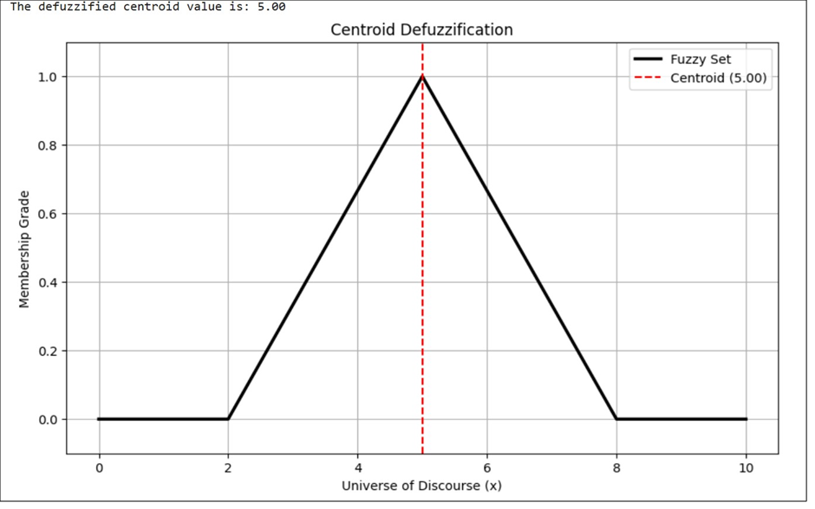

Program:
# Weighted Average Defuzzification import numpy as np import skfuzzy as fuzz import matplotlib.pyplot as plt

# 1. Define the universe of discourse (x-axis) x = np.arange(0, 11, 0.1)

# 2. Define the centers and weights centers = np.array([2, 5, 8]) weights = np.array([0.4, 0.8, 0.6])

# 3. Calculate the weighted average weighted_average = np.sum(centers * weights) / np.sum(weights) print(f"The defuzzified weighted average is: {weighted_average:.2f}") # 4. Define the symmetrical output membership functions # Each tuple [a, b, c] defines a triangular membership function low_mf = fuzz.trimf(x, [0, 2, 5]) medium_mf = fuzz.trimf(x, [2, 5, 8]) high_mf = fuzz.trimf(x, [5, 8, 10])

# 5. Visualize the result fig, ax = plt.subplots(figsize=(10, 6))

# Plot each fuzzy set ax.plot(x, low_mf, 'b', linewidth=1.5, label='Low') ax.plot(x, medium_mf, 'g', linewidth=1.5, label='Medium') ax.plot(x, high_mf, 'm', linewidth=1.5, label='High')

# Plot the centers of each membership function ax.plot(centers, np.array([1, 1, 1]), 'ko', label='Centers ($c_i$)')

# Plot the weighted average result as a vertical dashed line height_wa = fuzz.interp_membership(x, medium_mf, weighted_average) # Use one of the MFs for height ax.axvline(x=weighted_average, ymax=height_wa, color='r', linestyle='--', label=f'Weighted Average ({weighted_average:.2f})')

# Add labels, title, and legend ax.set_title('Weighted Average Defuzzification') ax.set_xlabel('Universe of Discourse (Output Value)') ax.set_ylabel('Membership Grade') ax.set_ylim(-0.1, 1.1) ax.legend() ax.grid(True)

# Display the plot plt.show()

Output:

